{

"bounce": true,

"click": true,

"deferred": true,

"delivered": true,

"dropped": false,

"enabled": true,

"group_resubscribe": true,

"group_unsubscribe": true,

"open": true,

"processed": true,

"spam_report": true,

"unsubscribe": true,

"url":"www.google.com"

}Google Spreadsheet Write

Objective

It is used to add/write data to the existing google spreadsheet.

UI

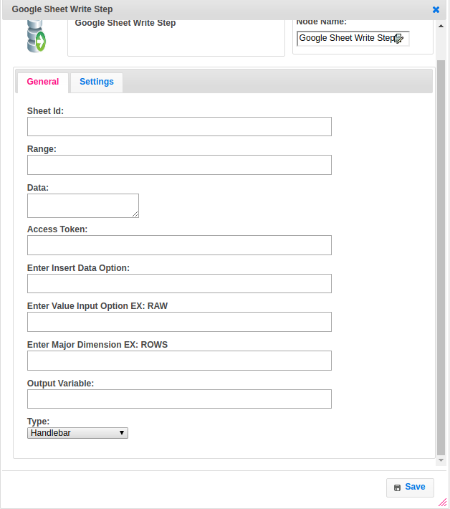

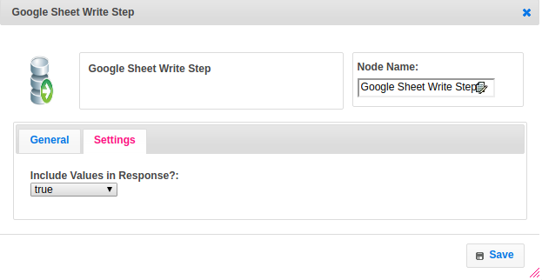

## Attributes

|  |  |
| --- | --- |
| **ATTRIBUTES** | **DESCRIPTION** |
| **Sheet Id** | The ID of the sheet to which the data to be added. |
| **Range** | The A1 notation of a range to search for a logical table of data. Values will be appended after the last row of the table. |
| **Data** | The data to be added to the spreadsheet. It should be in Array_Of_Arrays format. |
| **Access Token** | Token to verify the sheet’s Owner. |
| **Insert Data Option** | To determine how the input data should be inserted. |
| **Value Input Option** | To determine how the input data should be interpreted. |
| **Major Dimensions** | To determine if the arrays included are interpreted as arrays of columns or rows. |
| **Output Variable** | The variable to store the result. |
| **Type** | To select type as free marker template or handlebar |
| **Include Values In Response** | Determines if the update response should include the values of the cells that were appended. By default, responses do not include the updated values. |

## Executor Description

Generates URL based on the details provided and using access_token. Passing the input value(‘data’ field) to URL and returning the response body based on execution status whether the status is success or failure.

## Resource

More information about writing data to Google spreadsheet please refer the following link.

spreadsheetId